DWF Debt Recovery & Enforcement Seminar | 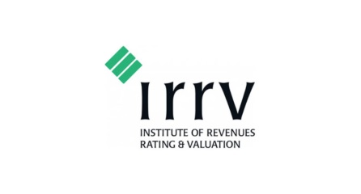  IRRV West Midlands

March 2018 | DWF Birmingham

https://www.dwf.law/contact-us/birmingham

TIME SLOT | PROGRAMME | SPEAKERS
10.00 – 10.30 | Coffee and Registration
10.30 – 10.45 | Welcome to DWF/Housekeeping and DWF Recoveries | David Scottow
10.45 – 11.00 | Welcome from IRRV West Midlands | Neil Jinks
11.00 – 11.30 | The View From Inside Revenues | Andrew Ludwig
11.30 – 12.00 | Coffee Break - Networking
12.00 – 12.30 | Civil Enforcement Update: Vulnerable Debtors | Laura Smith
12.30 – 1.30 | Networking Lunch
1.30 – 2.00 | Update on the Pre-Action Protocol (PAP)  Unpaid d Rents and HB Overpayments | Jeff Gledhill
2.00 – 2.30 | The Fixed Cost Regime & Online Court | James Perry
2.30 – 3.00 | Charitable Reliefs & Avoidance Schemes | Deborah Payne
3.00 – 3.15 | Ask The Experts: Panel Q&A/Summary/Close | All Speakers
3.15 – 3.30 | Coffee & Final Networking Opportunity

