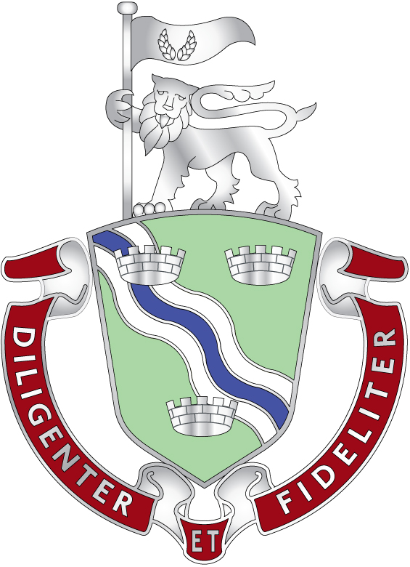
Thames Valley IRRV Association Day
Friday 26th April 2024
Jubilee Hall, Hartley Wintney, Hook, RG27 8RQ

Agenda

Time
12:30 | Arrival, networking and lunch | Lunch kindly provided by Rundles, Newlyn and Excel Civil Enforcement
13:30 | Sarah Naylor – Dukes Bailiffs Ltd | “Out of year – out of capacity”
14:00 | Nigel Blair - NEC | “Debt management”
14:30 | Break
15:00 | Dan Pearce – Telsolutions | “Changing behaviour of debtors post-covid”
15:30 | Paul Whyte – Whyte and Co. | “Civil enforcement industry – an update”
16:00 | Thames Valley AGM | Including election of new officers
*timings are approximate
Please let us know if you’ll be attending so we can arrange the catering. To book your place for the seminar, please contact Andy Taplin [andy.taplin@southwark.gov.uk] or Emma Bevington [emma.bevington@southwark.gov.uk]

